Experiment Number : 9 Date: 21-02-26

Implementation of a Java Program to import packages using different methods

Aim:
Write a Java program to import packages using different methods for different use cases.

PRE LAB EXERCISE
QUESTIONS
- How to import a single class and multiple classes from a package in Java?

(A) Importing a Single Class
Use the package name + class name.
Example: Importing only ArrayList from java.util:
import java.util.ArrayList;
class Demo {
public static void main(String[] args) {
ArrayList<Integer> list = new ArrayList<>();
}
}

(B) Importing Multiple Classes from the Same Package
Use the wildcard * to import all classes from that package.
Example:
import java.util.*;
class Demo {
public static void main(String[] args) {
ArrayList<Integer> list = new ArrayList<>();
HashMap<Integer, String> map = new HashMap<>();
}
}
* imports all classes inside the package but it does NOT import sub-packages

- Which package is always imported by default in every Java class?
java.lang package
It is automatically imported by the Java compiler into every program.
This package contains core classes like:
- String
- System
- Math
- Object
- Thread
- Wrapper classes (Integer, Double, etc.)
IN LAB EXERCISE
Objective
To understand and implement the Java packages using different methods and import them.
Problem
Define a package named ‘useFul’ with a class names ‘UseMe’ having following methods:
1) area()- To calculate the area of given shape.
2) salary()- To calculate the salary given basic Salary,da,hRA.
3) percentage()-To calculate the percentage given total marks and marks obtained.
4) Develop a program named ‘Package Use’ to import the above package ‘useFul’ and use the method area().
5) Develop a program named ‘manager’
Source Code
//Package Creation:
package useFull;
import java.util.*;
public class UseMe
{
Scanner obj=new Scanner(System.in);
public static void area()
{
class method{
void aos(int a)
{
System.out.print("\nArea of square with length "+a+" is "+(a*a));
}
void aor(int a,int b)
{
System.out.print("\nArea of reactangle with dimensions "+a+" & "+b+" is "+(a*b));
}
void aoc(int r)
{
double a=3.14*r*r;
}
System.out.print("\nArea of circle with radius "+r+" is "+a);
}
void aot(int a,int b)
{
float ar=(a*b)/2;
System.out.print("\nArea of triangle with dimensions "+a+" &"+b+" is "+ar);
} }
Scanner obj=new Scanner(System.in);
method m=new method();
System.out.print("\n1.Square\n2.Rectangle\n3.Circle\n4.Triangle\nSelect the shape\n");
int ch=obj.nextInt();
UseMe u=new UseMe();
switch(ch)
{
case 1:System.out.print("\nEnter the length of side of square : ");
int s=obj.nextInt();m.aos(s);
break;
case 2:System.out.print("\nEnter the dimensions of rectangle : ");
int l=obj.nextInt();
int b=obj.nextInt();
m.aor(l,b);
break;
case 3:System.out.print("\nEnter the radius of circle : ");
int r=obj.nextInt();
m.aoc(r);
break;
case 4:System.out.print("\nEnter the dimensions of triangle : ");
int ba=obj.nextInt();
int w=obj.nextInt();
m.aot(ba,w);
break; } }
public void salary()
{
int ba,da,hra;
System.out.print("\nEnter the basic salary : ");
ba=obj.nextInt();
System.out.print("\nEnter the dearness allowance :");
da=obj.nextInt();
System.out.print("\nEnter the house rent allowance : ");
hra=obj.nextInt();
System.out.print("\nThe total Gross salary of employee is : "+(ba+da+hra));
}
public void percentage()
{
int n,sum=0;
float p;
System.out.print("\nEnter the total number of subjects : ");
n=obj.nextInt();
int m[]=new int[n];
System.out.print("\nEnter the marks of "+n+" subjects : ");
for(int i=0;i<n;i++)
{
m[n]=obj.nextInt();
}
for(int i=0;i<n;i++)
{
sum=sum+m[i];
}
p=sum/n;
{
System.out.print("\nPercentahe of student : "+p);
}
}
}
//Package Implementation-1:
import useFull.UseMe;
class packageUse
{
public static void main(String args[])
{
UseMe o=new UseMe();o.area();
}
}

Output
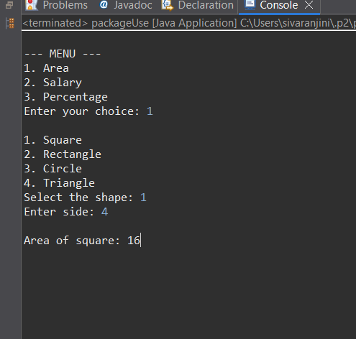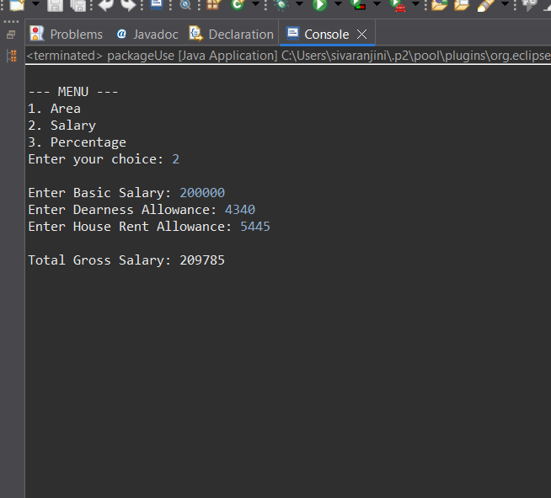
POST LAB EXERCISE
- Find the key differences between java.util and java.lang packages.
Feature | java.lang | java.util
Purpose | Contains fundamental/essential classes required for basic Java programming. | Contains utility classes that support data structures, collections, and utilities.
Automatic Import | Automatically imported in every Java program. | Not automatically imported — must be imported manually.
Examples of Classes | String, Math, Object, System, Thread, Wrapper classes (Integer, Double, etc.) | ArrayList, HashMap, Collections, Date, Scanner, Random, Stack, LinkedList
Type of Classes | Core language classes needed for JVM and basic operations. | Helper classes for advanced operations like data storage, searching, sorting, etc.
Main Use | Base functionality — strings, numbers, threads, exceptions, OOP core. | Data structures, algorithms, utilities, and tools for working with collections.

- List some of the subpackages of java.util
- java.util.concurrent — classes for multithreading and concurrency (Executor, Locks, etc.)
- java.util.concurrent.atomic — atomic (thread-safe) operations on variables.
- java.util.concurrent.locks — lock mechanisms for threads.
- java.util.function — functional interfaces for lambda expressions.
- java.util.regex — Regular expression classes (Pattern, Matcher).
- java.util.stream — Stream API for functional programming.
- java.util.jar — working with JAR files.
- java.util.prefs — user/system preference data.
- java.util.spi — service provider interfaces.
- java.util.zip — ZIP compression/decompression.

ASSESSMENT

Description | Max Marks | Marks Awarded
Pre Lab Exercise | 5
In Lab Exercise | 10
Post Lab Exercise | 5
Viva | 10
Total | 30
Faculty Signature

